1. Use Case Flow
   1. 7.1 Request to view statistics about major components

The User requests to view statistics about a major component (train, railway, hub, train station) of the simulation via the UI. The UI queries the simulation system to provide this information, updates its layout, and displays the data.

* 1. 7.2 Request to export data about simulation

The User requests to view statistics about the simulation via the simulation system through the UI. The File generator formats the the statistics for data modeling, and outputs them to a file.

1. Use Case Diagram

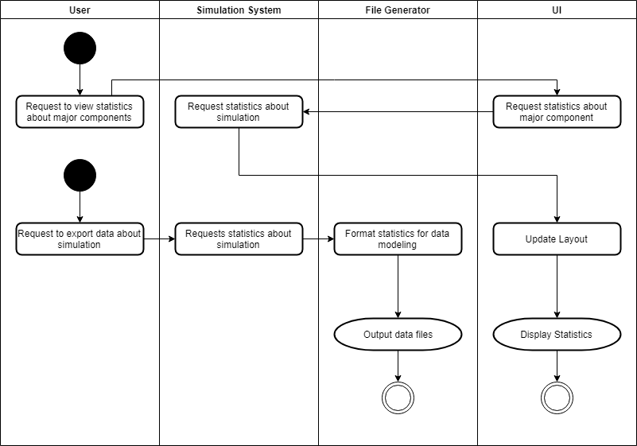

1. ERD

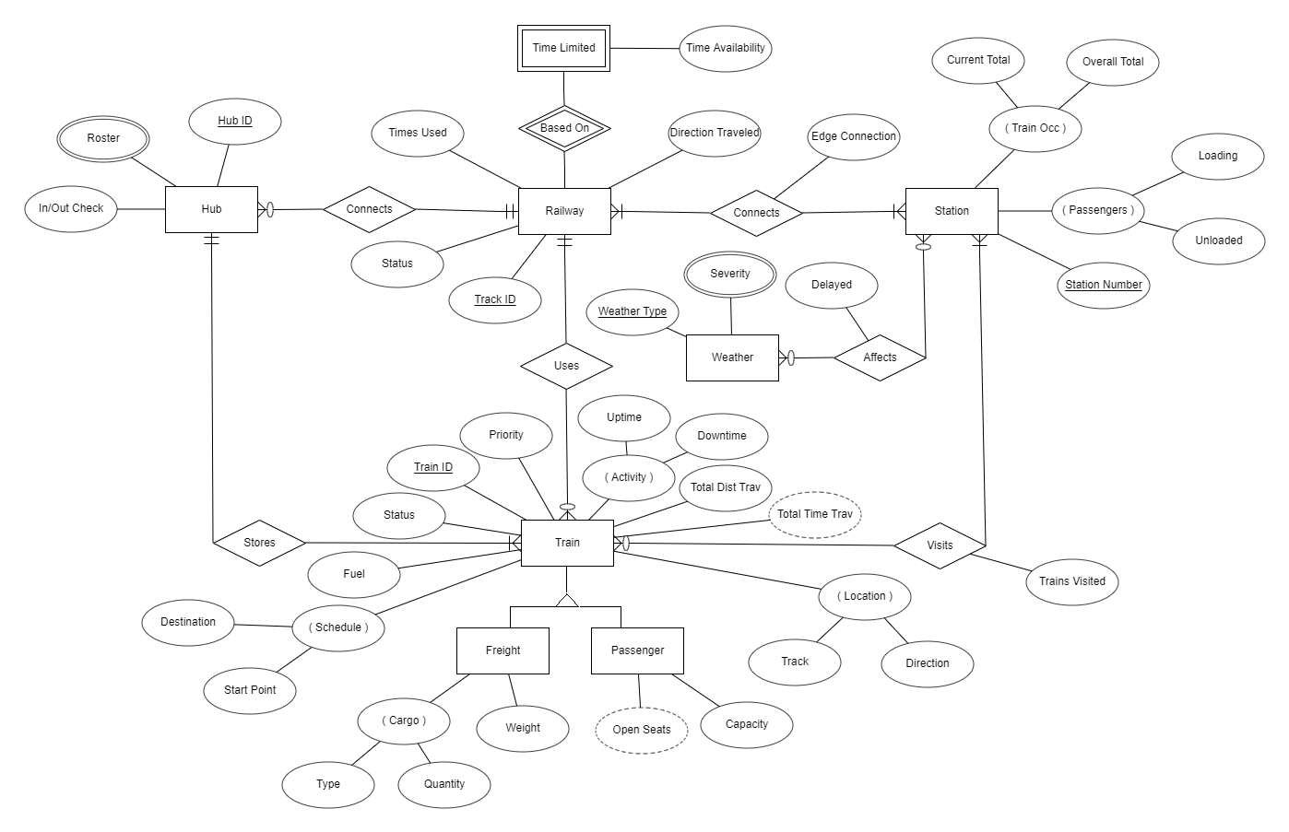

1. DFD
2. 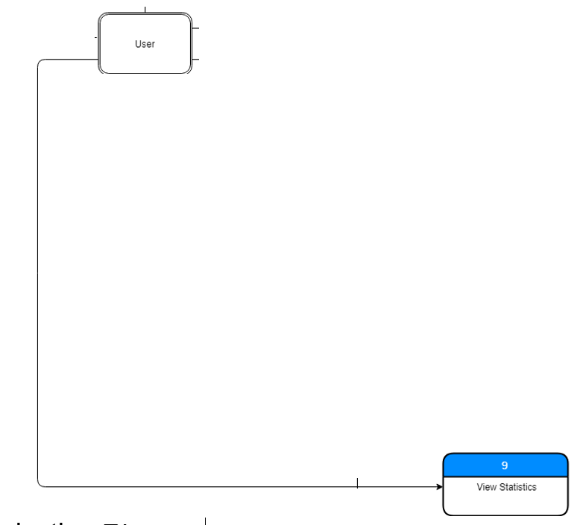
3. Communication Diagram

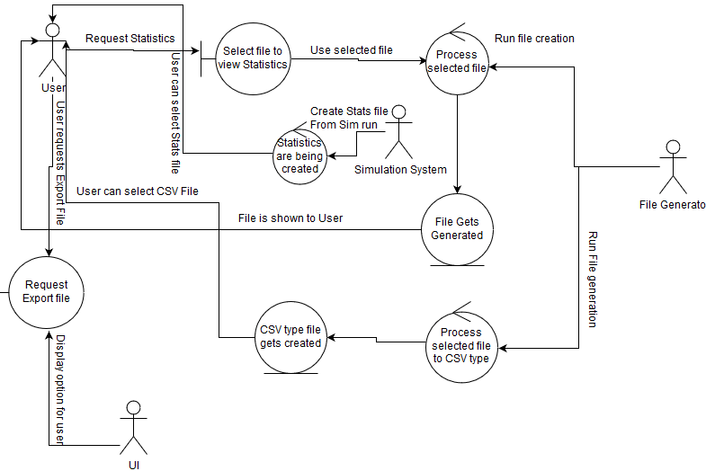

1. CRC Card
2. Class Diagram

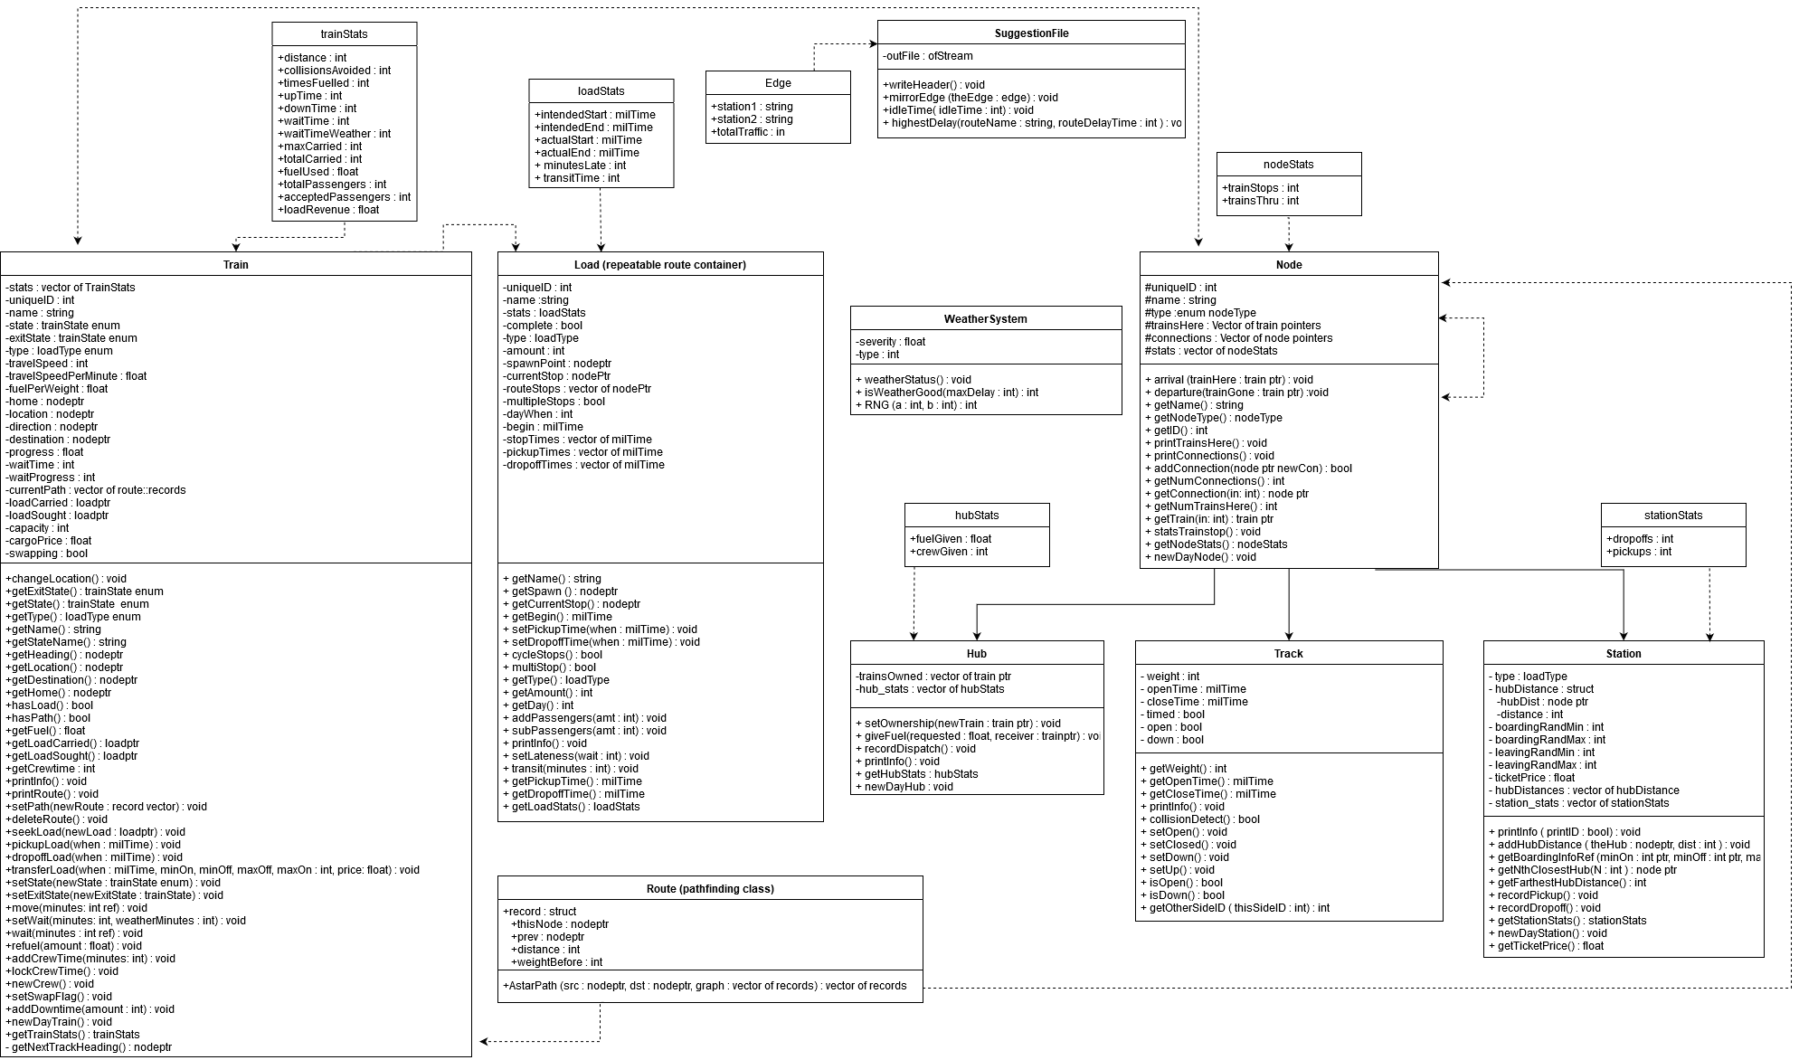N/A

1. Architecture Diagram

N/A

1. Algorithm

Before a train leaves a station it must

1. Sequence Diagram

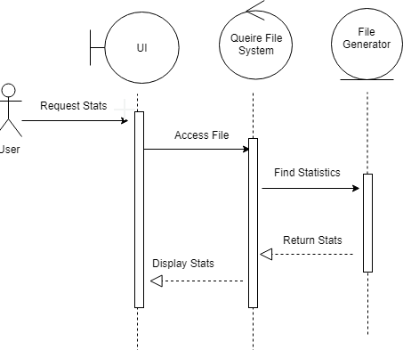

1. Code
2. Execution